ASSIGNMENT NO 14

1) write a command that puts the following values in their given order into the sales people table :City – San Jose cname – belt – null, c name – 1100.
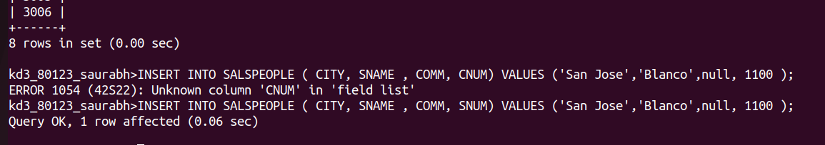

2) write a command that a removes all orders from customer Clemens from the Orders table.
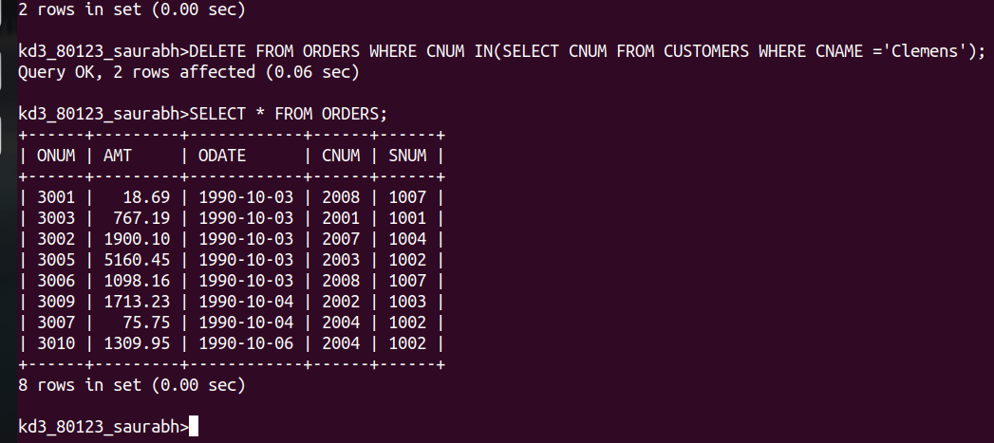

3) write a command that increases the rating of all customers in Rome by 100.
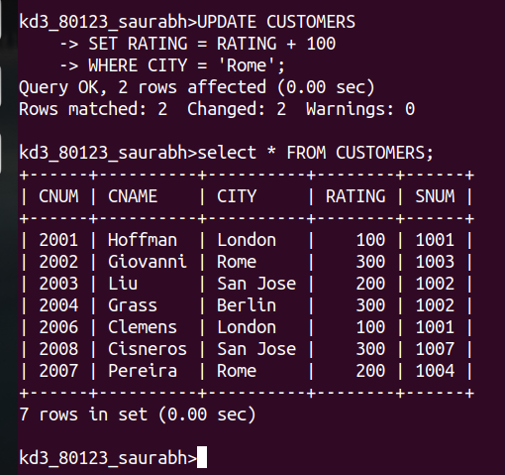
4) sales person Serres has left the company assign her customers to motika.
